*Corresponding Author:*

**Daniel P. Babin:** ORCiD: 0000-0002-8339-1312

Lamont Doherty Earth Observatory

Geochemistry Division

Columbia University

Department of Earth and Environmental Science

*Co-Authors:*

**Allison M. Franzese**Lamont Doherty Earth ObservatoryGeochemistry Division  
Hostos Community College  
Physical Sciences Unit, Natural Sciences Department

**Sidney R. Hemming** ORCiD:0000-0001-8117-2303

Lamont Doherty Earth ObservatoryGeochemistry Division

Columbia University

Department of Earth and Environmental Science

**Ian R. Hall** ORCiD: 0000-0001-6960-1419

Cardiff University

School of Earth and Ocean Sciences

**Leah J. LeVay** ORCiD: 0000-0003-3031-7079  
Texas A&M University  
International Ocean Discovery Program

**Stephen Barker** ORCiD: 0000-0001-7870-6431  
Cardiff University  
School of Earth and Ocean Sciences

**Luis Tejada**   
Hostos Community College  
Physical Sciences Unit, Natural Sciences Department  
**Margit H. Simon**NORCE Norwegian Research Centre  
Bjerknes Centre for Climate Research  
  
**Expedition 361 Scientists**

Keywords: Expedition 361, South African Climates, Site U1474, Natal Valley, Agulhas Current, Geochemistry, XRF Core Scanning

Data report: X-ray fluorescence core scanning of IODP Site U1474 sediments, Natal Valley, Southwest Indian Ocean

Daniel P. Babin 1, 2, Allison M. Franzese 1, 3, Sidney R. Hemming 1, 2, Ian R. Hall 4,Leah J. LeVay 5, Stephen Barker 4, Luis Tejada3, Margit H. Simon 6, and Expedition 361 Scientists

1. Lamont-Doherty Earth Observatory
2. Department of Earth and Environmental Sciences, Columbia University
3. Physical Sciences Unit, Natural Sciences Department, Hostos Community College,
4. School of Earth and Ocean Sciences, Cardiff University, United Kingdom
5. International Ocean Discovery Program
6. NORCE Norwegian Research Centre, Bjerknes Centre for Climate Research

# Abstract

X-ray fluorescence (XRF) core scanning was conducted on International Ocean Discovery Program Site U1474, located in the Natal Valley off the coast of South Africa. The data were collected at a 2 mm resolution along the 255 m length of the splice, but these settings resulted in noisy data. This problem was addressed by applying a 10-point running sum on the XRF data prior to converting peak area to element intensities. This effectively integrates 10 measurements into one, representing an average over 2 cm and significantly improving noise in the data. With 25 calibration samples, whose element concentrations were derived using Inductively Coupled Plasma-Optical Emission Spectrometry (ICP-OES), the XRF measurements were converted to concentrations using the Univariate Log-Ratio Calibration of Weltje & Tjallingii (2008). The resulting concentrations of terrigenously derived major elements (Al, Si, K, Ti, and Fe) are anti-correlated with Ca concentrations, indicating the main control on sediment chemistry is the variable proportions of terrigenous to in situ produced carbonate material.

# Introduction

XRF core-scanning is widely used in paleoceanography and provides qualitative, high-resolution, direct geochemical measurements along the length of a sediment or rock core. While log-ratios represent well the amount of variability in the data, there is a clear advantage to calibrating XRF data (Weltje, 2002; Weltje et al., 2015; Weltje & Tjallingii, 2008), which enables direct comparison to geochemical data gathered with other methods. The calibration process involves subsampling along the length of the core, determining absolute elemental concentrations using a different geochemical method, such as inductively coupled plasma mass spectrometry, and comparing these values to the counts derived by XRF.

International Ocean Discovery Program (IODP) Expedition 361 (South African Climates) Site U1474 was drilled 88 nmi southwest of Durban, South Africa in the Natal Valley, at 31°13.00′S, 31°32.71′E and 3045 m below sea level, and produced a record back to at least 6 Ma (Hall et al., 2017) (Figure 1). The site is located in the path of the Agulhas Current, a large western boundary current (70 Sv) flowing south along Africa’s southeast margin (Lutjeharms, 2006). The record was obtained with the intention of documenting changes in both Agulhas Current variability and southern African paleoclimate. The composition of sediment at Site U1474 is largely terrigenous (55–65%) and clay abundance is high (Hall et al., 2017). Likely terrigenous sediment contributors include river systems proximal to the core site, such as the Tugela, Mfolozi, and Mkumazi Rivers, which drain the nearby Drakensberg Mountains (Hall et al., 2017; Simon et al., 2015) (Figure 1). The Natal Valley also receives sedimentation from more distant sources, such as the Limpopo and Zambezi Rivers, based on the high 87Sr/86Sr ratio of the >63 µm fraction of Natal Valley sediment, which reflects the Archean age of the Kaapvaal and Zimbabwe Cratons that are eroded by the Zambezi and Limpopo Rivers (Franzese et al., 2006, 2009) (Figure 1). Sediment from these rivers is presumably transported to the Natal Valley via the Mozambique Current, estimated today to have a 15 Sv flux (Ridderinkhof et al., 2010) (Figure 1) and ultimately the Agulhas Current.

Work conducted by Simon et al. (2015) on a piston core collected near Site U1474 for the pre-site survey (CD-154-10-06P, 31°10.36′ S, 032° 08.91′ E, 3076 m water depth) used the Fe/K ratio of bulk sediment derived from XRF core scanning to monitor the changing character of the terrigenous fraction. Because K is more mobile during weathering than Fe (Kossoff et al., 2012) and the spatial distribution of Fe and K in surface marine sediments tends to reflect the wetness or dryness of proximal sediment sources (Govin et al., 2012), Simon et al. (2015) argued that the changing Fe/K ratio indicated changes in chemical weathering as a consequence of changing hydroclimatic conditions. They also found precessional variation in the intensity of chemical weathering of sediment, consistent throughout the 270 ky length of the record. A similar application of XRF core scanning on the 6 My record at Site U1474 could be useful in monitoring hydroclimate on longer timescales.

# Methods and Materials

In an effort to promote transparency and reproducibility in the geosciences, especially with large and cumbersome datasets such as XRF scans, the entirety of the process detailed in this work is documented on GitHub, a free online software version control platform commonly used for open source projects. This includes all of the raw data files, the XRF spectra for each scan, and element signal intensities from the ICP-OES, and all the code used to organize the data, calibrate the XRF scans, and produce figures. Each process is displayed in a IPython Jupyter Notebook, a web-based interactive computational environment. These can be examined by any reader in a web browser, or downloaded and re-processed by Python users. Each notebook can be viewed at <https://github.com/danielbabin/U1474_XRF_Data_Report> under “Notebooks.”

**2.1 Data Collection**

**2.1.1 XRF Core Scans**

An ITRAX Core Scanner (Croudace et al., 2006) in the Core Repository at Lamont-Doherty Earth Observatory was used to scan 213 archive half sections composing the Site U1474 splice. Each section was removed from refrigeration 30 minutes before measurement to allow the core to warm to room temperature. Surface roughness was removed from the core with a plastic card, and the core was covered with 4 μm thick Ultralene plastic film (SPEX Centriprep, Inc.) before being placed on the scanner, which is essential to minimize variation in parameter S (measurement geometry and specimen inhomogeneity) in the XRF calibration (Weltje & Tjallingii, 2008). Warming before adding the film helps prevent condensation on the film as condensation absorbs X-ray spectra, especially biasing light elements (Kido et al., 2006). X-ray illumination area was set at 2 mm in the down-core direction and 2 cm in the cross-core direction, and the scan was run down the center of the split core section half. Measurement spacing was set at 2 mm, the voltage at 30 kV, and the amperage at 55 mA, with an exposure time of 2 seconds using a Cr tube.

Due to shipping error, one core (Sections U1474E-17H-1 to 3; splice depth 221.6–225.50 m core composite depth below seafloor [CCSF]) did not reach Lamont-Doherty Earth Observatory. Consequently, data from this interval is missing.

**2.1.2 Calibration Samples**

Discrete 10 cm3 samples were taken from the working halves for (non-destructive) shipboard measurements of moisture and density (MAD). Because water content is one of the key variables that affects measured XRF intensities, we used a subset of the MAD sample residues for this calibration. After the XRF scanning was complete, we selected 25 of the MAD residues to capture the range of variability seen in the XRF scan data. Because the MAD samples were taken from Hole A, not the splice, we used the magnetic susceptibility records to tie each MAD sample to a precise depth interval on the archive halves that were used for scanning (Table 1). This correlation for each MAD sample is documented on GitHub in the notebook “mad_correlation.ipynb”. The 25 discrete samples were digested using a standard lithium metaborate flux fusion method along with a set of six powdered rock standards and six procedural blanks. Element concentrations were measured by Inductively Coupled Plasma-Optical Emission Spectrometry (ICP-OES) using the Agilent 720 axial ICP-OES at the Lamont Doherty Earth Observatory-American Museum of Natural History ICPMS Lab, for which routine precision is 1–2%. Signal intensities were corrected for blanks and instrumental drift, then converted to concentrations using the accepted values for the six rock standards (Table 2). The raw data and data reduction process for calculating elemental concentrations for the calibrations samples is documented on GitHub in the notebook “xrf_calibration_samples_reduction.ipynb”.

**2.1.3 Calcium Carbonate Percent**

An aliquot of the bulk moisture and density samples was powdered and measured for percent CaCO3 using a UIC CM5012 CO2 Coulometer at Lamont Doherty Earth Observatory’s Core Repository. Precision is determined to be <4% by replicate measurements every 10 samples. These measurements of percent CaCO3 are combined with measurements of CaCO3 performed aboard the *JOIDES Resolution*. These data are listed in Table 3.

**2.2 XRF Data Processing**

**2.2.1 Pre-Processing: Running Sum Spectra**

For this study, we focus only on the major elements detectable with the ITRAX: Al, Si, K, Ca, Ti, and Fe. The results of our XRF core scanning at 2 mm resolution can be found in Table 4. Unfortunately, even for the major elements, the low dwell time chosen (2 seconds) yielded noisy records, especially for light elements like Al (Figure 2). Two seconds is the minimum recommended dwell time with the ITRAX Core Scanner. We chose this short dwell time, applied at a high resolution (2 mm), because we had a large volume of core to analyze and limited funds for analysis time. Fortunately, our high-resolution scanning allowed us to integrate the raw spectral data across a wider depth interval, increasing the height of our spectra, and improving the signal-to-noise ratio.

To accomplish this, we access the raw spectral data, in the form of an “.spe” file, created with each measurement. The file contains a single vector of intensities at different energy wavelengths. We import all the spectral intensities from each “.spe” file (~750 for 1.5 m of core) from a single section into a data structure, and take a 10-measurement running sum at each energy level across that data structure. Taking a 10-measurement running sum across these data, collected every 2 mm for 2 seconds, simulates a 2 cm exposure for 20 seconds. The section “offset” assigned to these integrated measurements represents the depth of the median (5th) measurement out of every 10 exposures integrated. This process was repeated for the 213 sections scanned. Some sections had measurements with very low total spectra intensities (the sum of each element in the spectra). These resulted from measuring air at the tops or bottoms of sections or cracks in the core. All measurements with total spectral intensities lower than 300,000 were dropped for this reason. The Python code using these steps is available on GitHub in the notebook “xrf_pre-processing.ipynb.”

For the ITRAX Core Scanner, converting a spectra of energy intensities to element intensities involves fitting the observed spectra from a measurement with a model and computing the relevant area under the spectral peaks. This is done using the software Q-Spec, provided by ITRAX and Cox Analytical Systems for XRF Data Reduction (Croudace et al., 2006). To optimize the fit for several measurements (for example, along the length of a core section), the ITRAX software sums the spectra from each measurement in a section and outputs a “sumspectra” .spe file. To optimize the model fit for our 213 sections, we averaged the intensities of our 213 sumspectra files. This average sumspectra was then fit using the Q-spec software. We chose elements for the spectral model that minimized mean-squared error (MSE). The parameters “keV/channel,” “energy offset,” “FWHM slope,” “FWHM offset,” and “FWHM cutoff” were also optimized to minimize MSE. We found that this method provides the highest quality record of element-intensity continuity in depth-space, minimizing jumps between sections. The MSE parameter provides a continuous assessment of how well the model fits each measurement. The results of this data processing can be found in Table 5. The Q-spec settings file (.dfl” file type) that we used for our data reduction can be found in the GitHub repository for this paper, under the subdirectory “Settings.”

Section positions were first converted into core depth below seafloor (CSF-A), and then into the core composite depth below seafloor (CCSF) used for the splice. No pre-processing steps, outlier removal, or filtering were necessary beyond the steps previously mentioned. The final result is 11,877 measurements of elemental intensities along 250 m of core. While we only focus on major elements here (Al, Si, K, Ca, Ti, and Fe) an extensive suite of elements not suitable for calibration are available in the full XRF data tables (Table 4, Table 5). Table 4 contains the 2 mm-2 second XRF data. Table 5 contains the 2 cm-20 second integrated XRF dataset.

The XRF data are shown in depth in Figures 3 and 4. Figure 3 shows individual element intensities for both the 2 cm-20 second dataset (full color) and the 2 mm-2 second (paler colors) dataset. Figure 4 presents element intensities from both datasets normalized to Ca intensity. These figures clearly visualize the noise reduction offered by the 2 cm integration of the raw spectra.

**2.3 XRF Core Scaning Data Calibration to Concentrations**

The relative abundances provided by the XRF in “counts” were converted to concentrations with a calibration dataset of 25 samples (Table 6, Figures 4 and 5). The conversion was made using the Univariate Log-ratio Calibration (ULC)of Weltje & Tjallingii (2008), with Ca counts and concentrations in the denominator of each element ratio. We chose the simpler ULC as opposed to the more sophisticated Multivariate Log-ratio Calibration (MLC) of Weltje et al. (2015) due to the relative sparse spacing of our calibration samples compared to the total length of our core. Concentrations are reported as weight-percent-element oxides. The Python code used for the calibration process, including the calculation of α and β parameters, is available on GitHub in the notebook “xrf_calibration.ipynb.” Model parameters α and β are available in Table 7.

The ULC is designed to calibrate element ratios, not necessarily individual element concentrations. But, if the elements in the collection of ratios are assumed to compose the entire sample, the relative concentrations of each element can be calculated. To ensure that the resulting concentrations derived from the XRF core scanning data reflect the concentrations of our calibration samples as closely as possible, we normalized the sum of each calibrated XRF measurement to 96.2%, the average sum of Al2O3 + SiO2 + K2O + CaO +TiO2 + Fe2O3 in the 25 calibration samples. This simply reflects the fact that the XRF did not measure Na2O and MgO, which sum to 3.8 % on average in the calibration dataset.

The results of the calibration are shown in depth in Figure 4 and Figure 5. Figure 4 shows individual element intensities. Figure 5 presents element intensities from both datasets normalized to Ca intensity. Black circles along each depth series are the concentrations and element ratios from the calibration samples.

**3.0 Results**

**3.1 Data Quality**

Figure 2 showing individual element intensities, indicates a few sections with unusually low counts, highlighted with gray bars (U1474D-4H-1A, U1474D-8H-3A, U1474D-11H-4A, U1474D-11H-5A). We attribute these anomalous measurements to malfunctions with the ITRAX scanner. The sections cannot be rescanned because these anomalous data were not discovered until after the cores were shipped back to Kochi Core Centre in Japan. However, while counts of individual element intensities are affected by this malfunction, ratios seem less affected (Figure 3, Figure 6). Figure 6 shows, on the left, signal intensity for each major element across a section with a scanning error and low counts (Section U1474D-8-3; section signal colored orange). The right panels show how, when plotted as element ratios, the ratios from the adjacent core sections join together, making the element ratio-depth series continuous. As ratios are the typical application of XRF data, we argue these sections may be used with caution.

Figure 7 compares the concentrations measured on the calibration samples with the XRF measurements at the appropriate depth and includes the ratios of the raw counts (Figure 7A), the log-ratios of the calibration and the XRF counts (Figure 7B), and ratios of the results and the calibrated XRF ratios (Figure 7C). For each element ratio, there is a strong correlation with an intercept at zero, within bootstrapped uncertainty.

As mentioned previously, the ULC works best for ratios, but individual element concentrations can be derived if the collection of ratios is assumed to compose the entire sample, summed, and normalized. Figure 8 shows how effectively our calibration yielded individual element concentrations. Most elements have high quality calibrations, with R2 coefficients greater than 0.53, and intercepts at or near zero within bootstrapped uncertainty intervals. Only titanium has a lower R2 coefficient. Titanium counts have a strong relationship with concentrations from the calibration sample; however, the relationship with XRF-derived concentrations is weaker.

**3.2 Description of Results**

For marine sediment, CaO concentration at Site U1474 is low, ranging from 13-41% (Figure 4D). CaO concentration derived CaCO3 coulometry (Table 3) are plotted alongside the XRF data as white squares (Figure 4D), and the CaO concentration from both methods at identical depths is cross plotted in Figure 9. The results indicate that most of the Ca is borne within CaCO3. By calculating the difference between total CaO and CaCO3 borne CaO for each sample, we estimate an average terrigenous CaO content of approximately 5%. CaO abundance is lowest between 100 and 170 m CCSF. There is a large excursion toward higher CaO deposition between 10 and 20 m CCSF.

Elements derived from the continental crust, borne in terrigenous phases, vary inversely with Ca content (Figure 4). The element with the greatest variability in the core scan dataset is K (Figure 4C), varying by more than a factor of 2 through the core. From 250–175 m CCSF, K content is low, about 1.25%, compared to the rest of the record (Figure 4C). From 170–100 m CCSF, K increases to ~1.75%, overprinted by two low frequency excursions to even higher values. From 100–20 m CCSF, K concentration declines gradually to a minimum of ~0.75 %. Above this interval, K content increases again. Long term trends in variability of the other terrigenously derived elements (Al, Si, Ti, and Fe) largely follow the pattern for K described above (Figure 4A, B, E, F). The covariance of the terrigenously derived elements and anti-correlation of calcium carbonate indicates that the main control on the chemical composition of sediment at Site U1474 is the variable input of terrigenous material.

**Acknowledgments**

This research used samples and/or data provided by the International Ocean Discovery Program (IODP). We thank the International Ocean Drilling Program and the Expedition 361 sailing scientists and staff for the collection of core material. Funding for XRF scanning was provided by IODP. The staff operating the ITRAX core scanner at the Lamont-Doherty Earth Observatory Core Repository, Clara Chang and Nicole Anest, were extremely helpful in the XRF data collection process. We thank individuals from Lamont Doherty Earth Observatory’s Climate and Life (2016) High School Intern Program: Andrew T. Celli, Elmina David, Ayla K. Markowski, Sonja O'Brien, Taiya Sharif, and Tess N. Strohm who aided with the long hours of core scanning. We thank an anonymous reviewer for their helpful input.

**References**

Croudace, I. W., Rindby, A., & Rothwell, R. G. (2006). ITRAX: description and evaluation of a new multi-function X-ray core scanner. Geological Society, London, Special Publications, 267(1), 51 LP – 63. <https://doi.org/10.1144/GSL.SP.2006.267.01.04>

Flanagan, F. J. (1984). Three USGS mafic rock references samples, W-2, DNC-1, and BIR-1.

Franzese, A. M., Hemming, S. R., Goldstein, S. L., & Anderson, R. F. (2006). Reduced Agulhas Leakage during the Last Glacial Maximum inferred from an integrated provenance and flux study. Earth and Planetary Science Letters, 250(1), 72–88. <https://doi.org/https://doi.org/10.1016/j.epsl.2006.07.002>

Franzese, A. M., Hemming, S. R., & Goldstein, S. L. (2009). Use of strontium isotopes in detrital sediments to constrain the glacial position of the agulhas retroflection. Paleoceanography. <https://doi.org/10.1029/2008PA001706>

Govin, A., Holzwarth, U., Heslop, D., Ford Keeling, L., Zabel, M., Mulitza, S., et al. (2012). Distribution of major elements in Atlantic surface sediments (36 N--49 S): Imprint of terrigenous input and continental weathering. Geochemistry, Geophysics, Geosystems, 13(1).

Hall, I. R., Hemming, S. R., LeVay, L. J., Barker, S., Berke, M. A., Brentegani, L., et al. (2017). Site U1474, 361(September). <https://doi.org/10.14379/iodp.proc.361.103.2017>

Imai, N., TERASHIMA, S., ITOH, S., & ANDO, A. (1996). 1996 COMPILATION OF ANALYTICAL DATA ON NINE GSJ GEOCHEMICAL REFERENCE SAMPLES, “SEDIMENTARY ROCK SERIES.” Geostandards Newsletter, 20(2), 165–216. <https://doi.org/10.1111/j.1751-908X.1996.tb00184.x>

Kido, Y., Koshikawa, T., & Tada, R. (2006). Rapid and quantitative major element analysis method for wet fine-grained sediments using an XRF microscanner. Marine Geology, 229(3), 209–225. <https://doi.org/https://doi.org/10.1016/j.margeo.2006.03.002>

Kossoff, D., Hudson-Edwards, K. A., Dubbin, W. E., & Alfredsson, M. (2012). Major and trace metal mobility during weathering of mine tailings: Implications for floodplain soils. Applied Geochemistry, 27(3), 562–576. https://doi.org/https://doi.org/10.1016/j.apgeochem.2011.11.012

Lutjeharms, J. R. E. (2006). The agulhas current. The Agulhas Current. <https://doi.org/10.1007/3-540-37212-1>

McLennan, S. M., & Taylor, S. R. (1980). Geochemical standards for sedimentary rocks: Trace-element data for U.S.G.S. standards SCo-1, MAG-1 and SGR-1. Chemical Geology, 29(1–4), 333–343. <https://doi.org/10.1016/0009-2541(80)90029-7>

Pretorius, W., Weis, D., Williams, G., Hanano, D., Kieffer, B., & Scoates, J. (2006). Complete Trace Elemental Characterisation of Granitoid (USGS G-2, GSP-2) Reference Materials by High Resolution Inductively Coupled Plasma-Mass Spectrometry. Geostandards and Geoanalytical Research, 30(1), 39–54. <https://doi.org/10.1111/j.1751-908X.2006.tb00910.x>

Ridderinkhof, H., Werf, P. M. Van Der, Ullgren, J. E., Aken, H. M. Van, Leeuwen, P. J. Van, & Ruijter, W. P. M. De. (2010). Seasonal and interannual variability in the Mozambique Channel from moored current observations, 115. <https://doi.org/10.1029/2009JC005619>

Simon, M. H., Ziegler, M., Bosmans, J., Barker, S., Reason, C. J. C., & Hall, I. R. (2015). Eastern South African hydroclimate over the past 270,000 years. Scientific Reports. <https://doi.org/10.1038/srep18153>

Weltje, G. J. (2002). Quantitative analysis of detrital modes: statistically rigorous confidence regions in ternary diagrams and their use in sedimentary petrology. Earth-Science Reviews, 57(3–4), 211–253.

Weltje, G. J., & Tjallingii, R. (2008). Calibration of XRF core scanners for quantitative geochemical logging of sediment cores: Theory and application. Earth and Planetary Science Letters. <https://doi.org/10.1016/j.epsl.2008.07.054>

Weltje, G. J., Bloemsma, M. R., Tjallingii, R., Heslop, D., Röhl, U., & Croudace, I. W. (2015). Prediction of geochemical composition from XRF core scanner data: a new multivariate approach including automatic selection of calibration samples and quantification of uncertainties. In Micro-XRF Studies of Sediment Cores (pp. 507–534). Springer.

**Figures**

**Figure 1:**

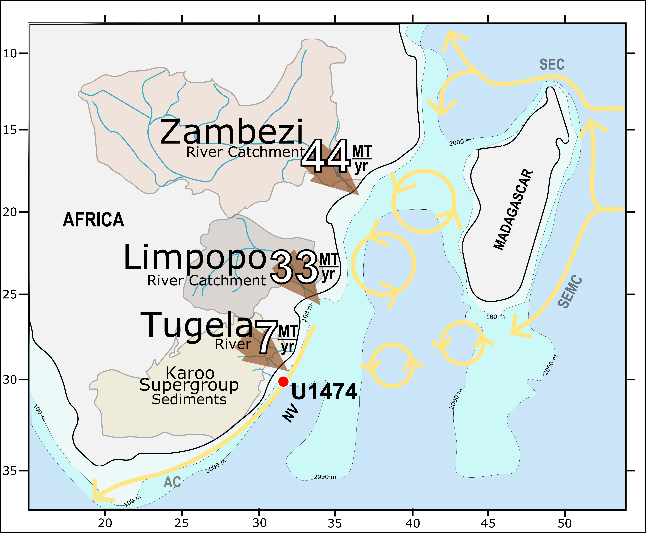

Drainage configuration and oceanography of southern Africa. The Zambezi and Limpopo are Africa’s largest rivers draining into the Indian Ocean, draining 44 and 33 Mt of sediment annually [Milliman and Meade, 1983]. Sediment from those rivers could be transported to Site U1474 first by the Mozambique Channel (MC) eddies (yellow rings) transporting 15 Sv (Ridderenkoff et al., 2010), and ultimately via the strong Agulhas Current (AC) (Lutjeharms, 2006). The Tugela River and other, smaller rivers, drain the Drakensberg mountains, flanking the southeastern African Margin. The mountains are composed of dominantly sedimentary rock of Paleozoic age called the Karoo Supergroup [Johnson et al., 1996]. These sediments could all be deposited into the SW-NE striking Natal Valley (NV), the location for Site U1474. Mapped are the 100 m and the 2000 m isobaths. SEC = South Equatorial Current. SEMC = South East Madagascar Current.

**Figure 2:**

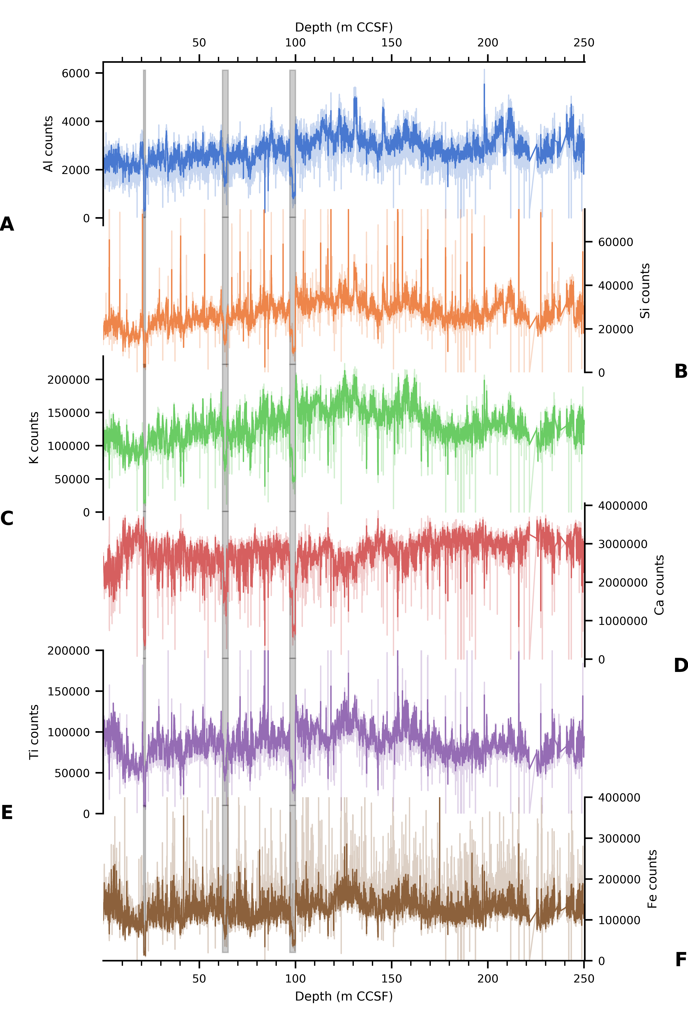

**Figure 2:**

Raw XRF data in depth series for each element. The series plotted with pale colors come from the 2 mm-2 sec dataset. The dark colors show the data from the integrated 2 cm-20 sec dataset. Elements are A) Aluminum, B) Silicon, C) Potassium, D) Calcium, E) Titanium, F) Iron. Gray bars highlight the four sections with anomalously low counts.

**Figure 3:**

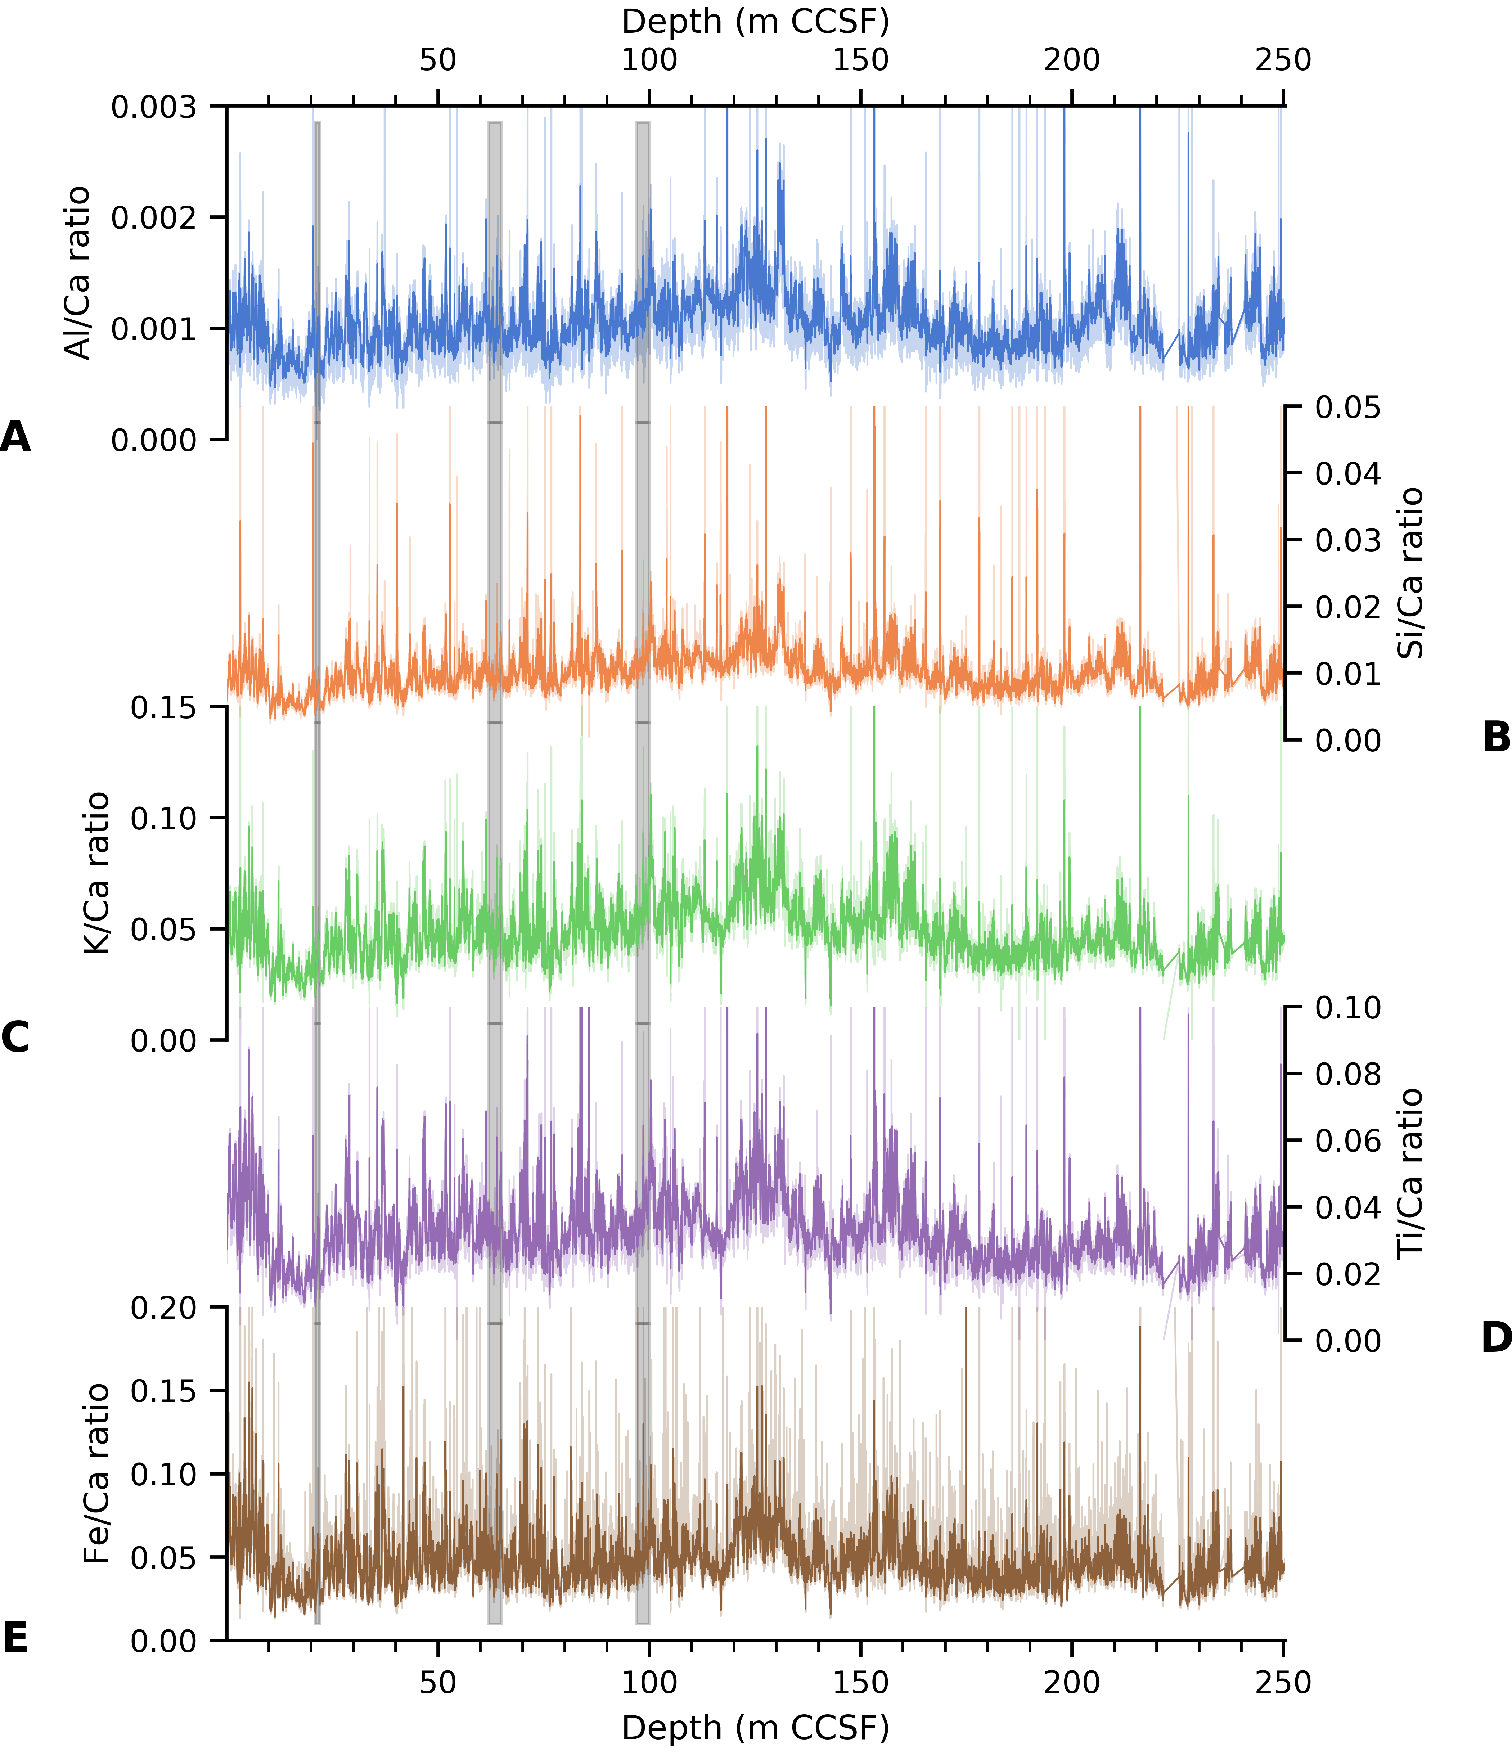

**Figure 3:**

Raw XRF data in depth series for each element normalized to Ca counts. The series plotted with pale colors come from the 2 mm-2 sec dataset. The dark colors show the data from the integrated 2 cm-20 sec dataset. Ratios are A) Al/Ca, B) Si/Ca, C) K/Ca, D) Ti/Ca, E) Fe/Ca. Gray bars highlight the four sections with anomalously low counts. The sections do not stand out when presented in ratio form (see Figure 6).

# Figure 4:

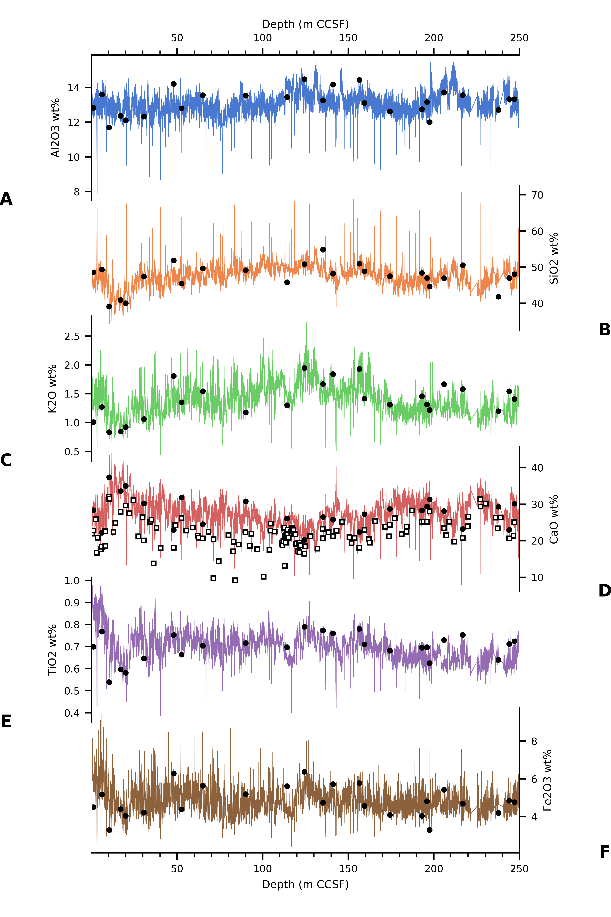

**Figure 4:**

The calibrated XRF data in depth series for each element oxide. Black circles show the calibration sample concentrations. Elements are A) Aluminum, B) Silicon, C) Potassium, D) Calcium. The white squares with black edges are Calcium oxide percent derived from the CaCO3 percent data, E) Titanium, F) Iron. Data are presented in wt% oxide.

**Figure 5:**

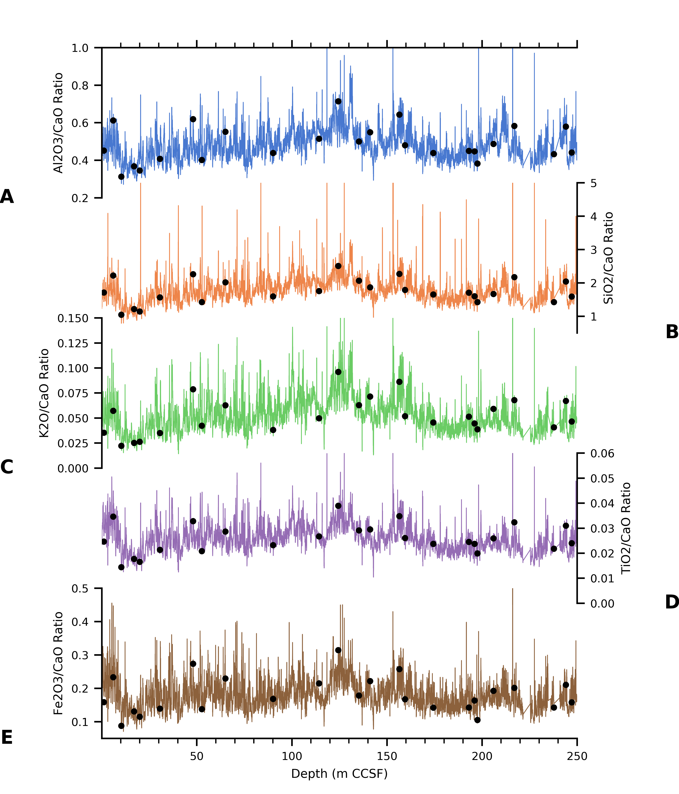

**Figure 5:**

The calibrated XRF data in depth series for each element ratio, normalized to CaO. Black circles show the calibration sample concentrations. Ratios are A) Al2O3/CaO, B) SiO2/CaO, C) K2O/CaO, D) TiO2/CaO, E) Fe2O3/CaO. Data are expressed in wt% oxide.

**Figure 6:**

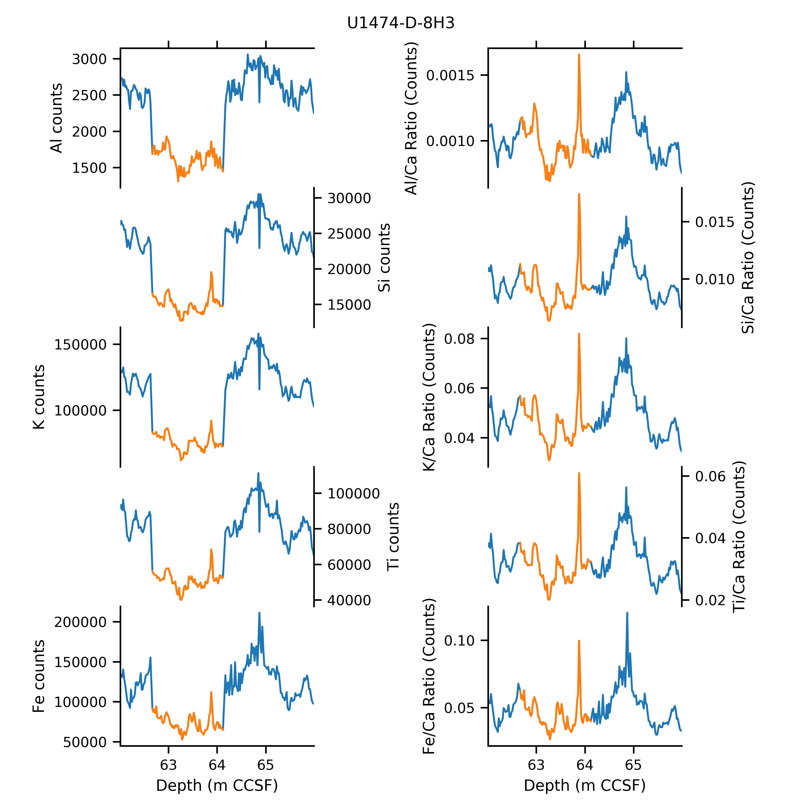

**Figure 6:**

The ITRAX scanner experienced problems during the scans of four core sections: U1474D-4H-1, U1474D-8H-3, U1474D-11H-4, and U1474D-11H-5. The signal from Section U1474D-8H-3 is colored orange in all panels. The adjacent sections are blue. **(Left)** When only the signal intensity is plotted, Section U1483D-8H-3 has low counts that do not fit the depth series. **(Right)** The element ratios are contiguous with the adjacent sections in depth series.

**Figure 7:**

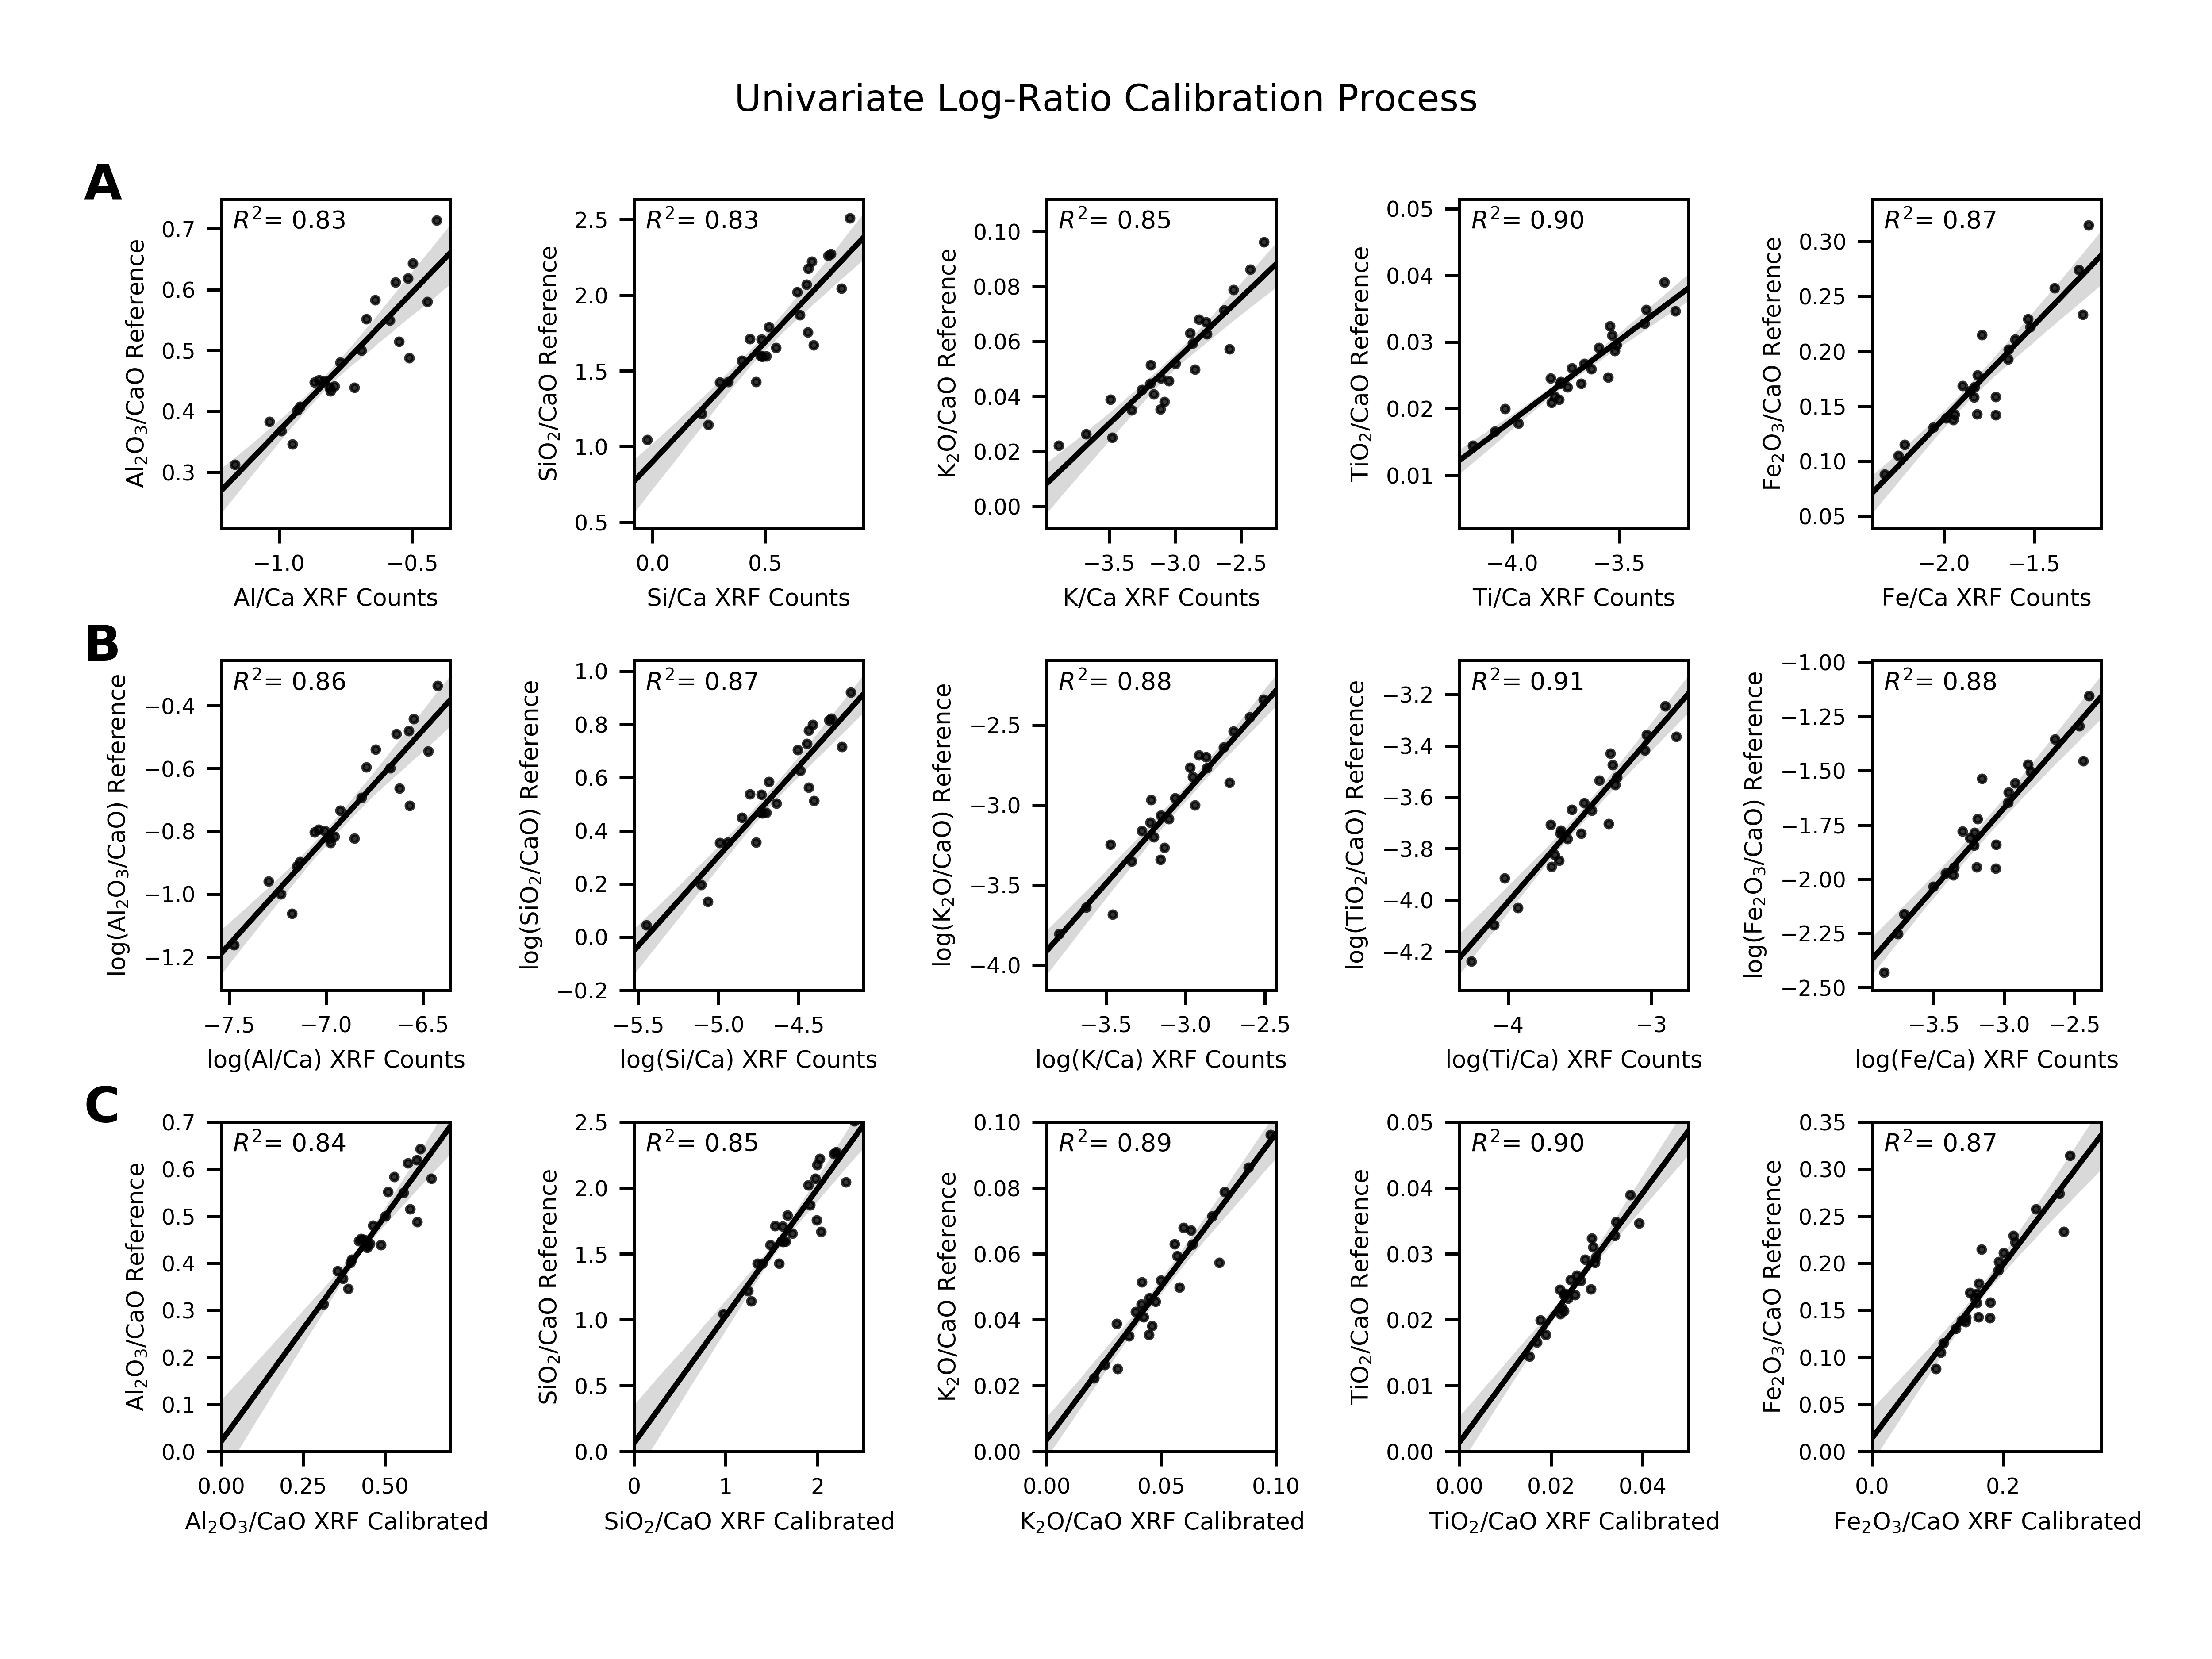

**Figure 7:**

A comparison of the counts derived from the XRF spectra to the concentration ratios from the calibration samples after each step in the XRF data reduction procedure provides a quality check. A) 2 cm-20 sec dataset, unprocessed. B) Log ratios of both concentrations and counts. C) Calibrated ratios. The grey shaded interval for all plots represents the 95% confidence interval regression model computed by bootstrapping the data 1000 times. Generated using the Python package Seaborn’s “regplot” function.

**Figure 8:**

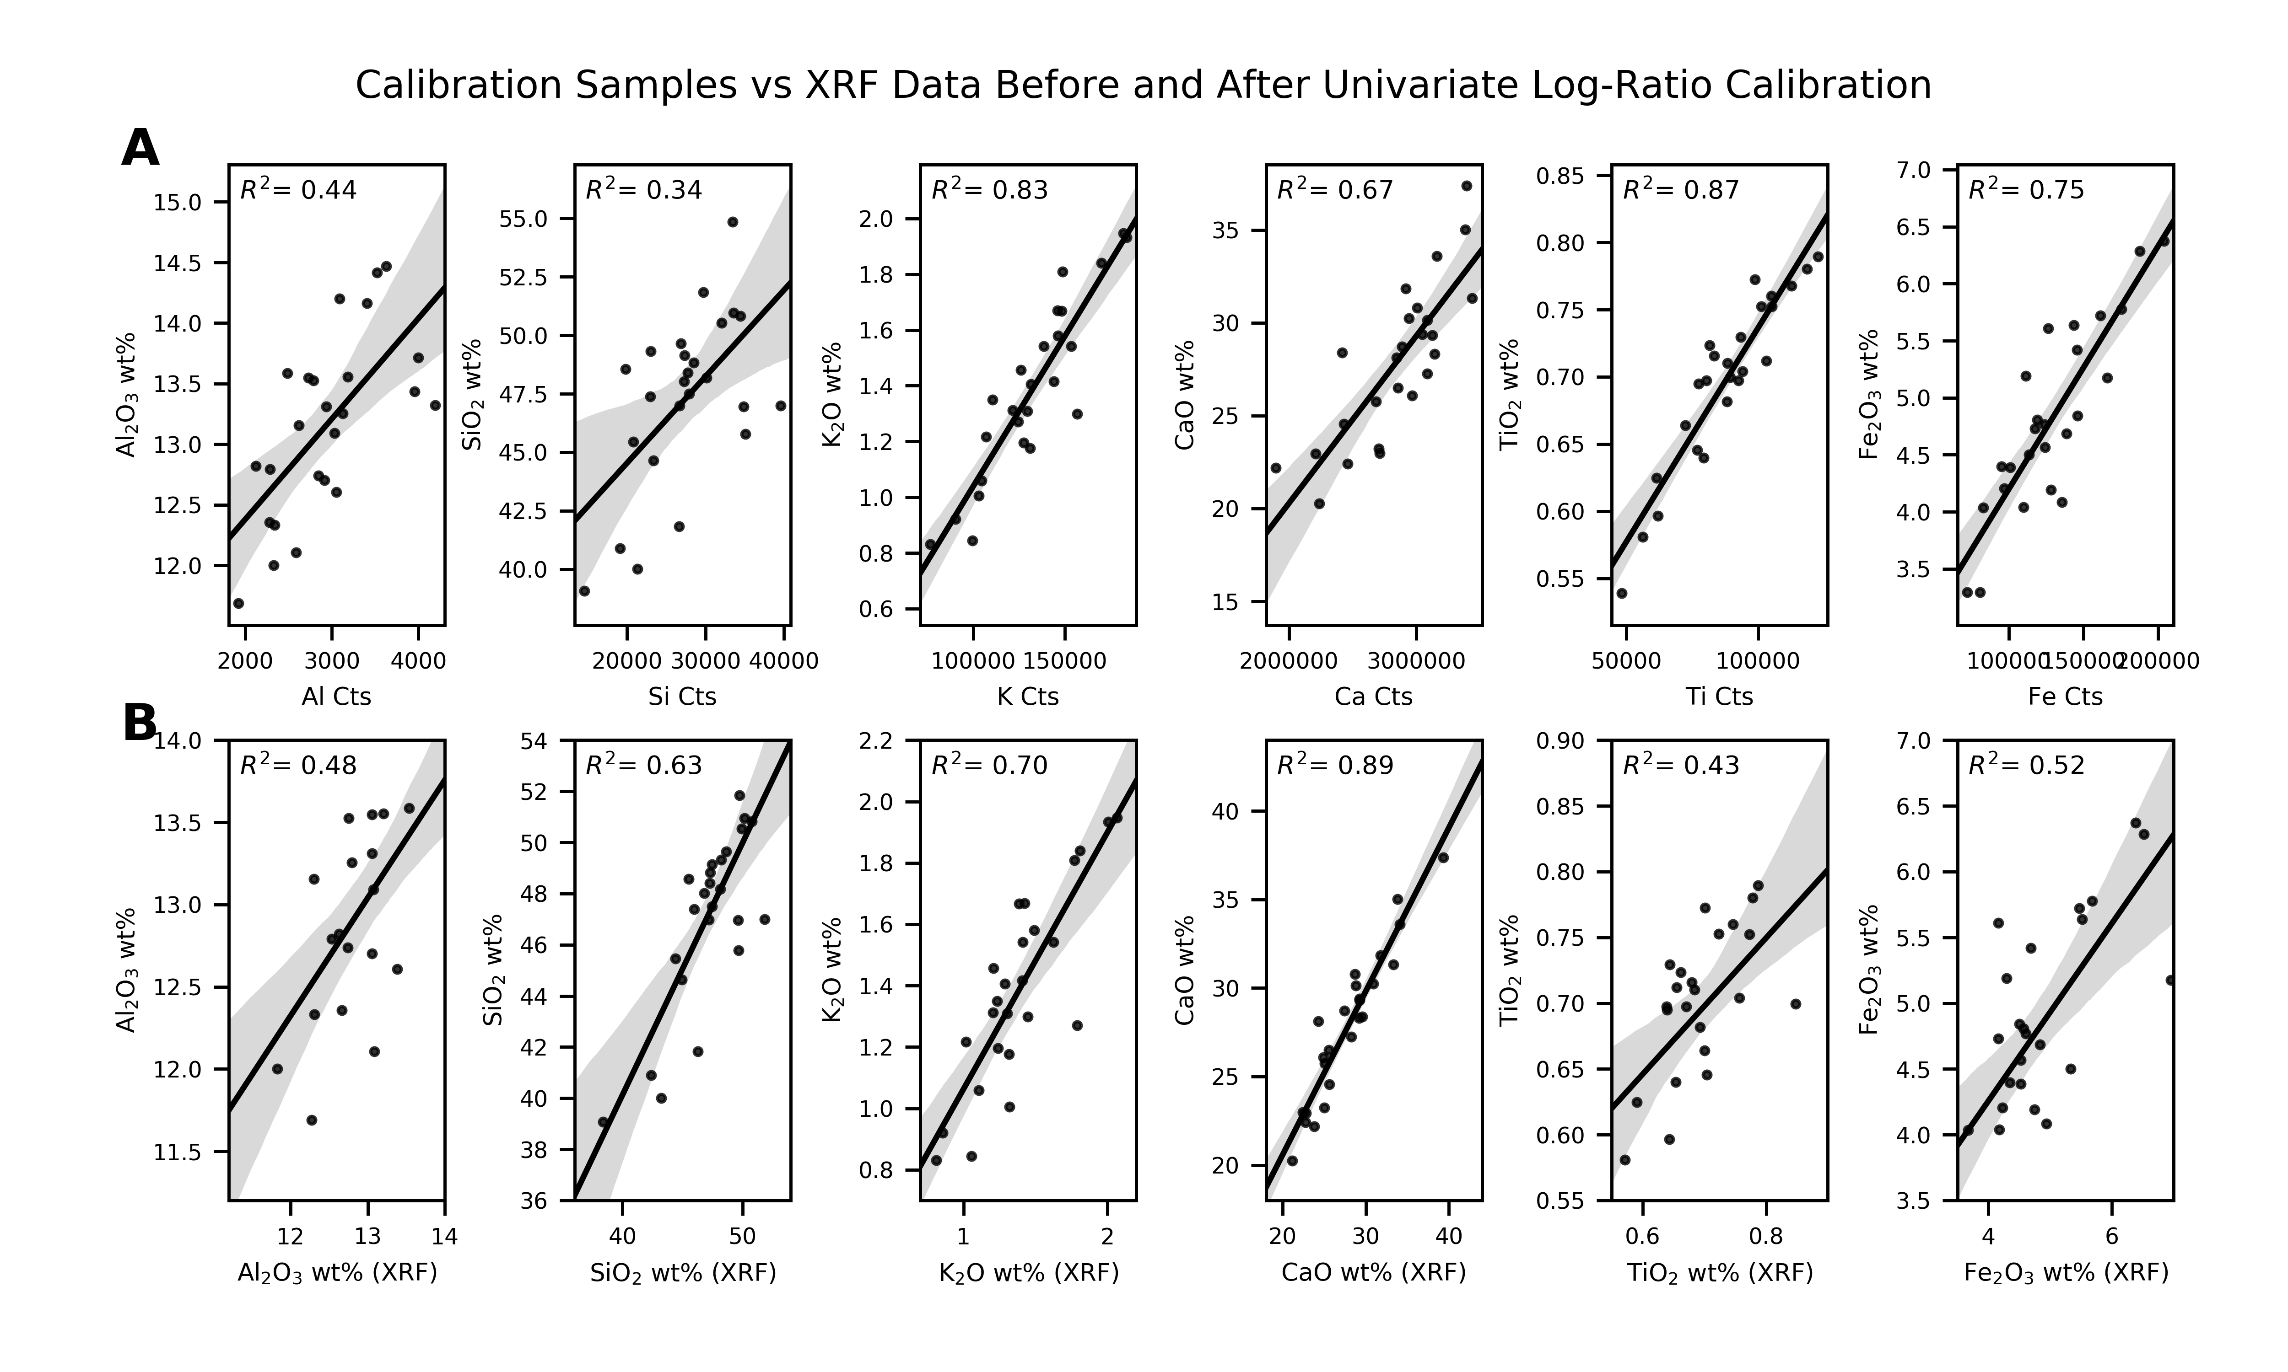

**Figure 8:**

A comparison of the XRF data to calibration samples using individual element concentrations A) before calibration and B) after the calibration. The grey shaded interval for all plots represents the 95% confidence interval regression model computed by bootstrapping the data 1000 times. Generated using the Python package Seaborn’s “regplot” function.

**Figure 9:**

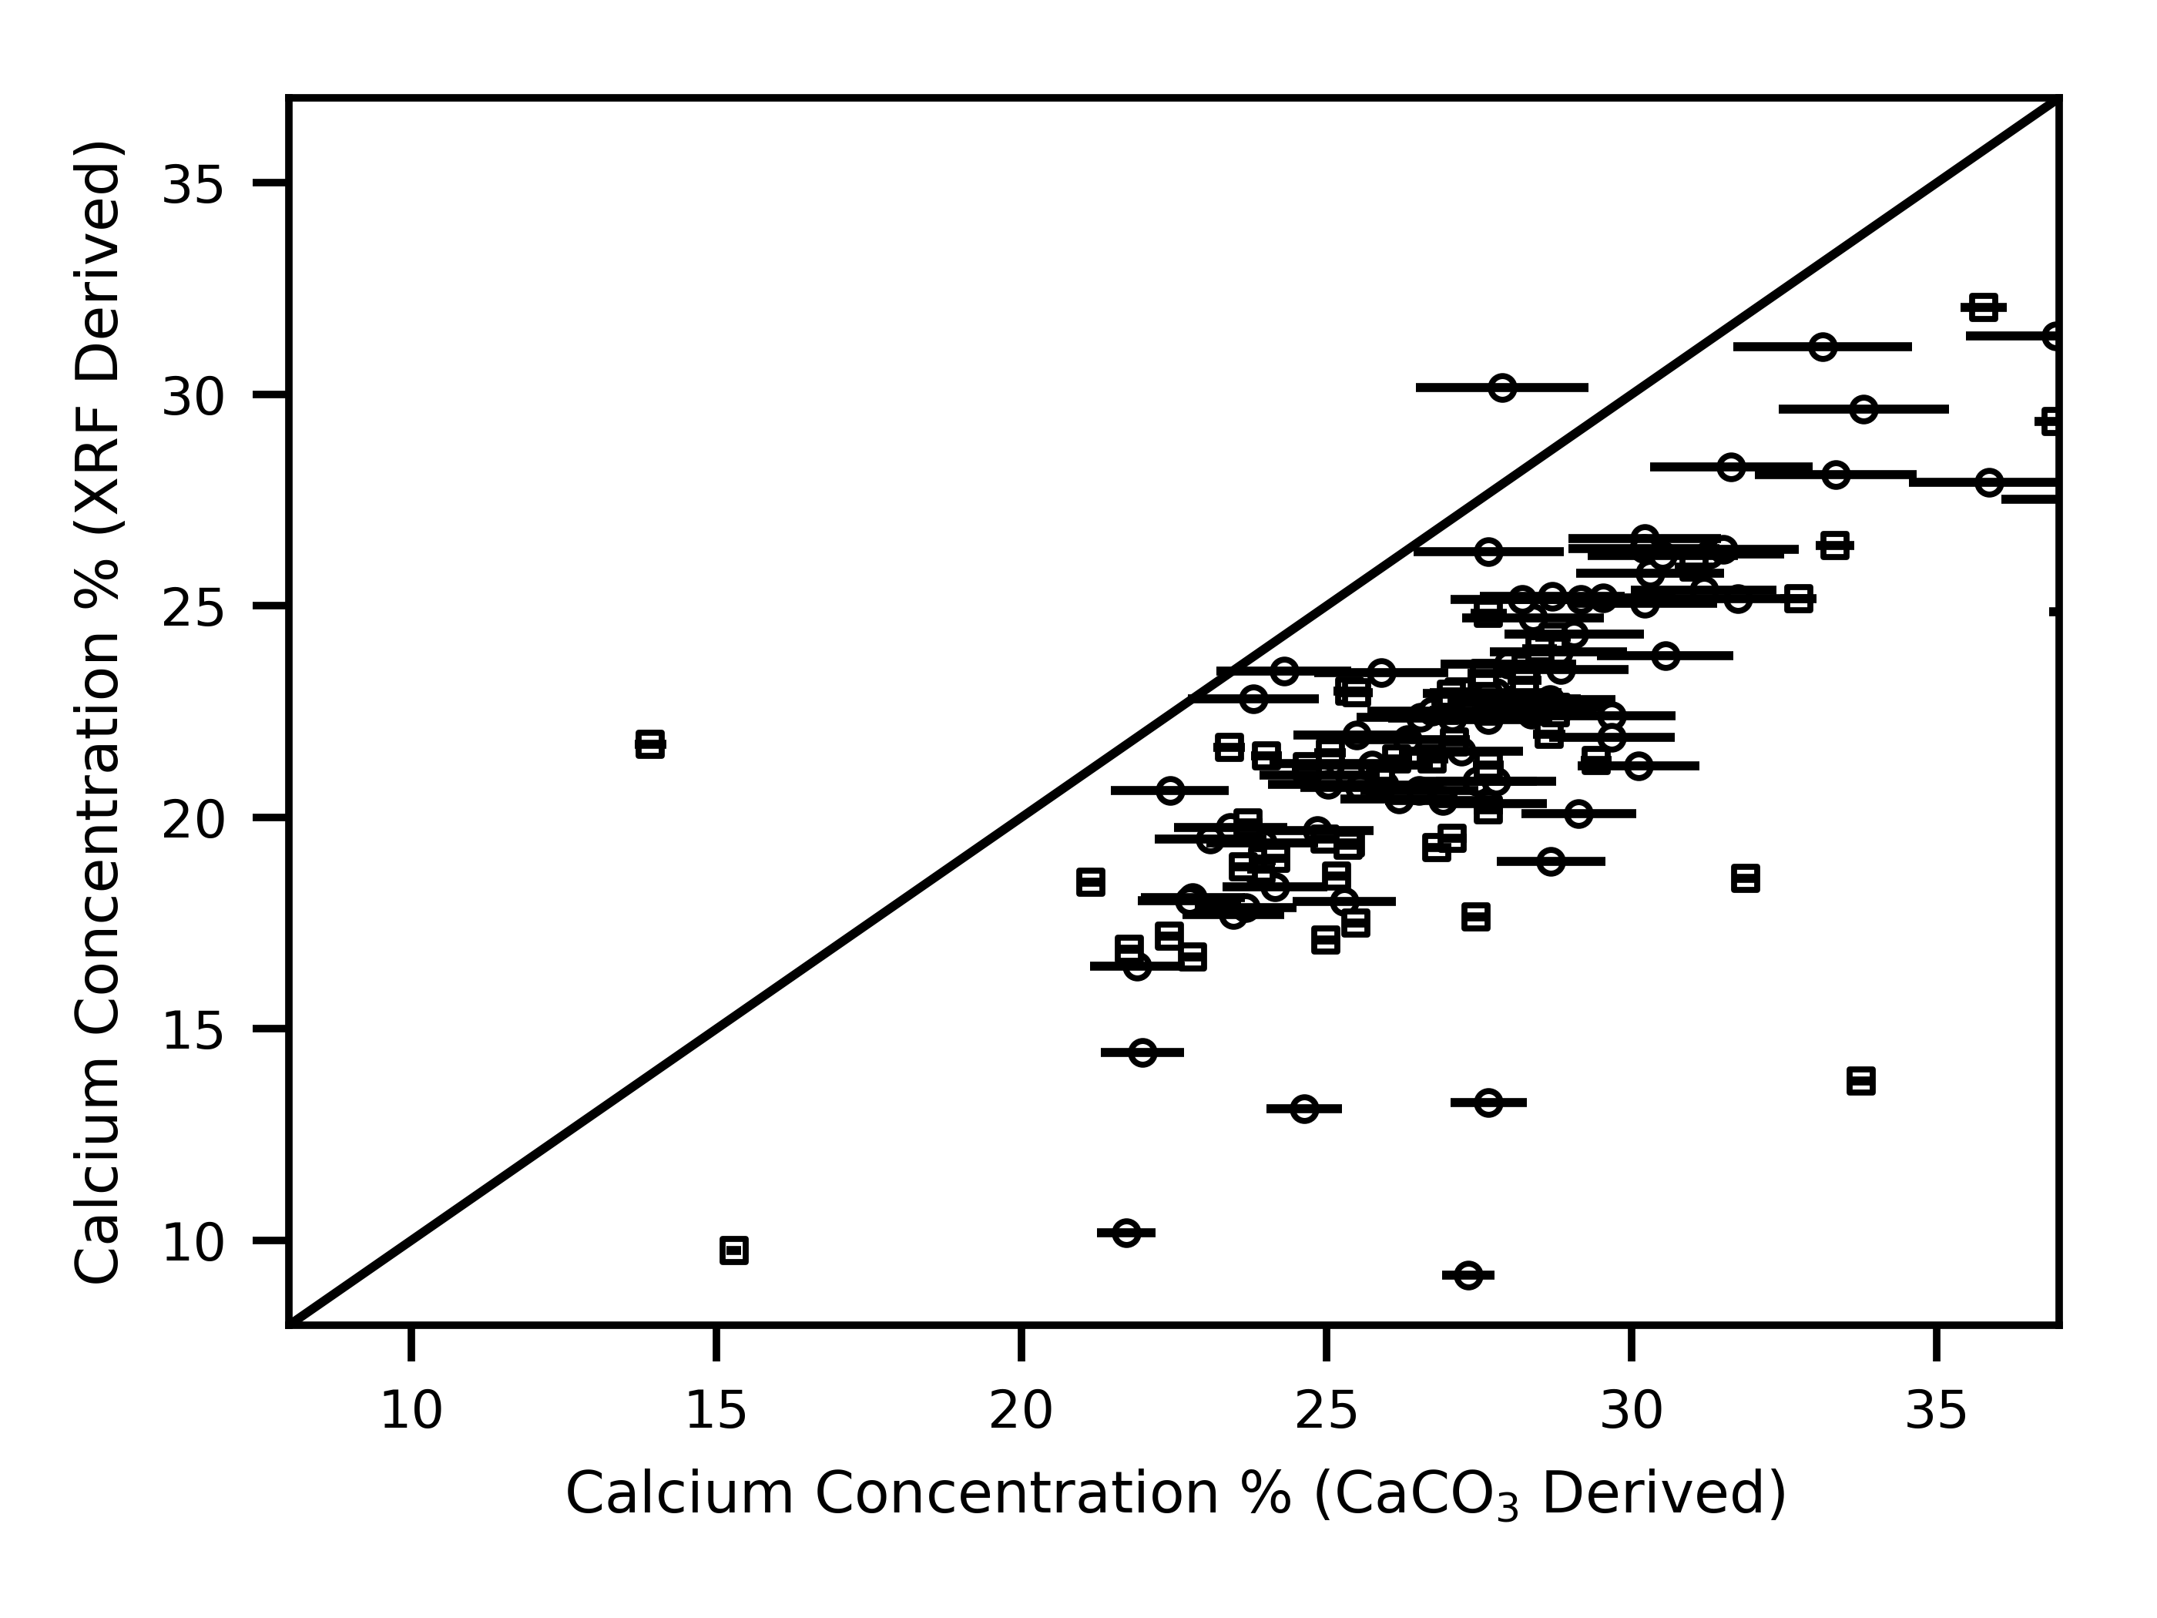

**Figure 9:**

Comparison of CaO concentration derived by XRF core scanning and CaO concentration calculated from %CaCO3. Squares are measurements made onboard the *JOIDES Resolution*, circles are from this study. Error bars represent precision at 1 standard deviation, estimated by replicates. The 1:1 line is shown in black.